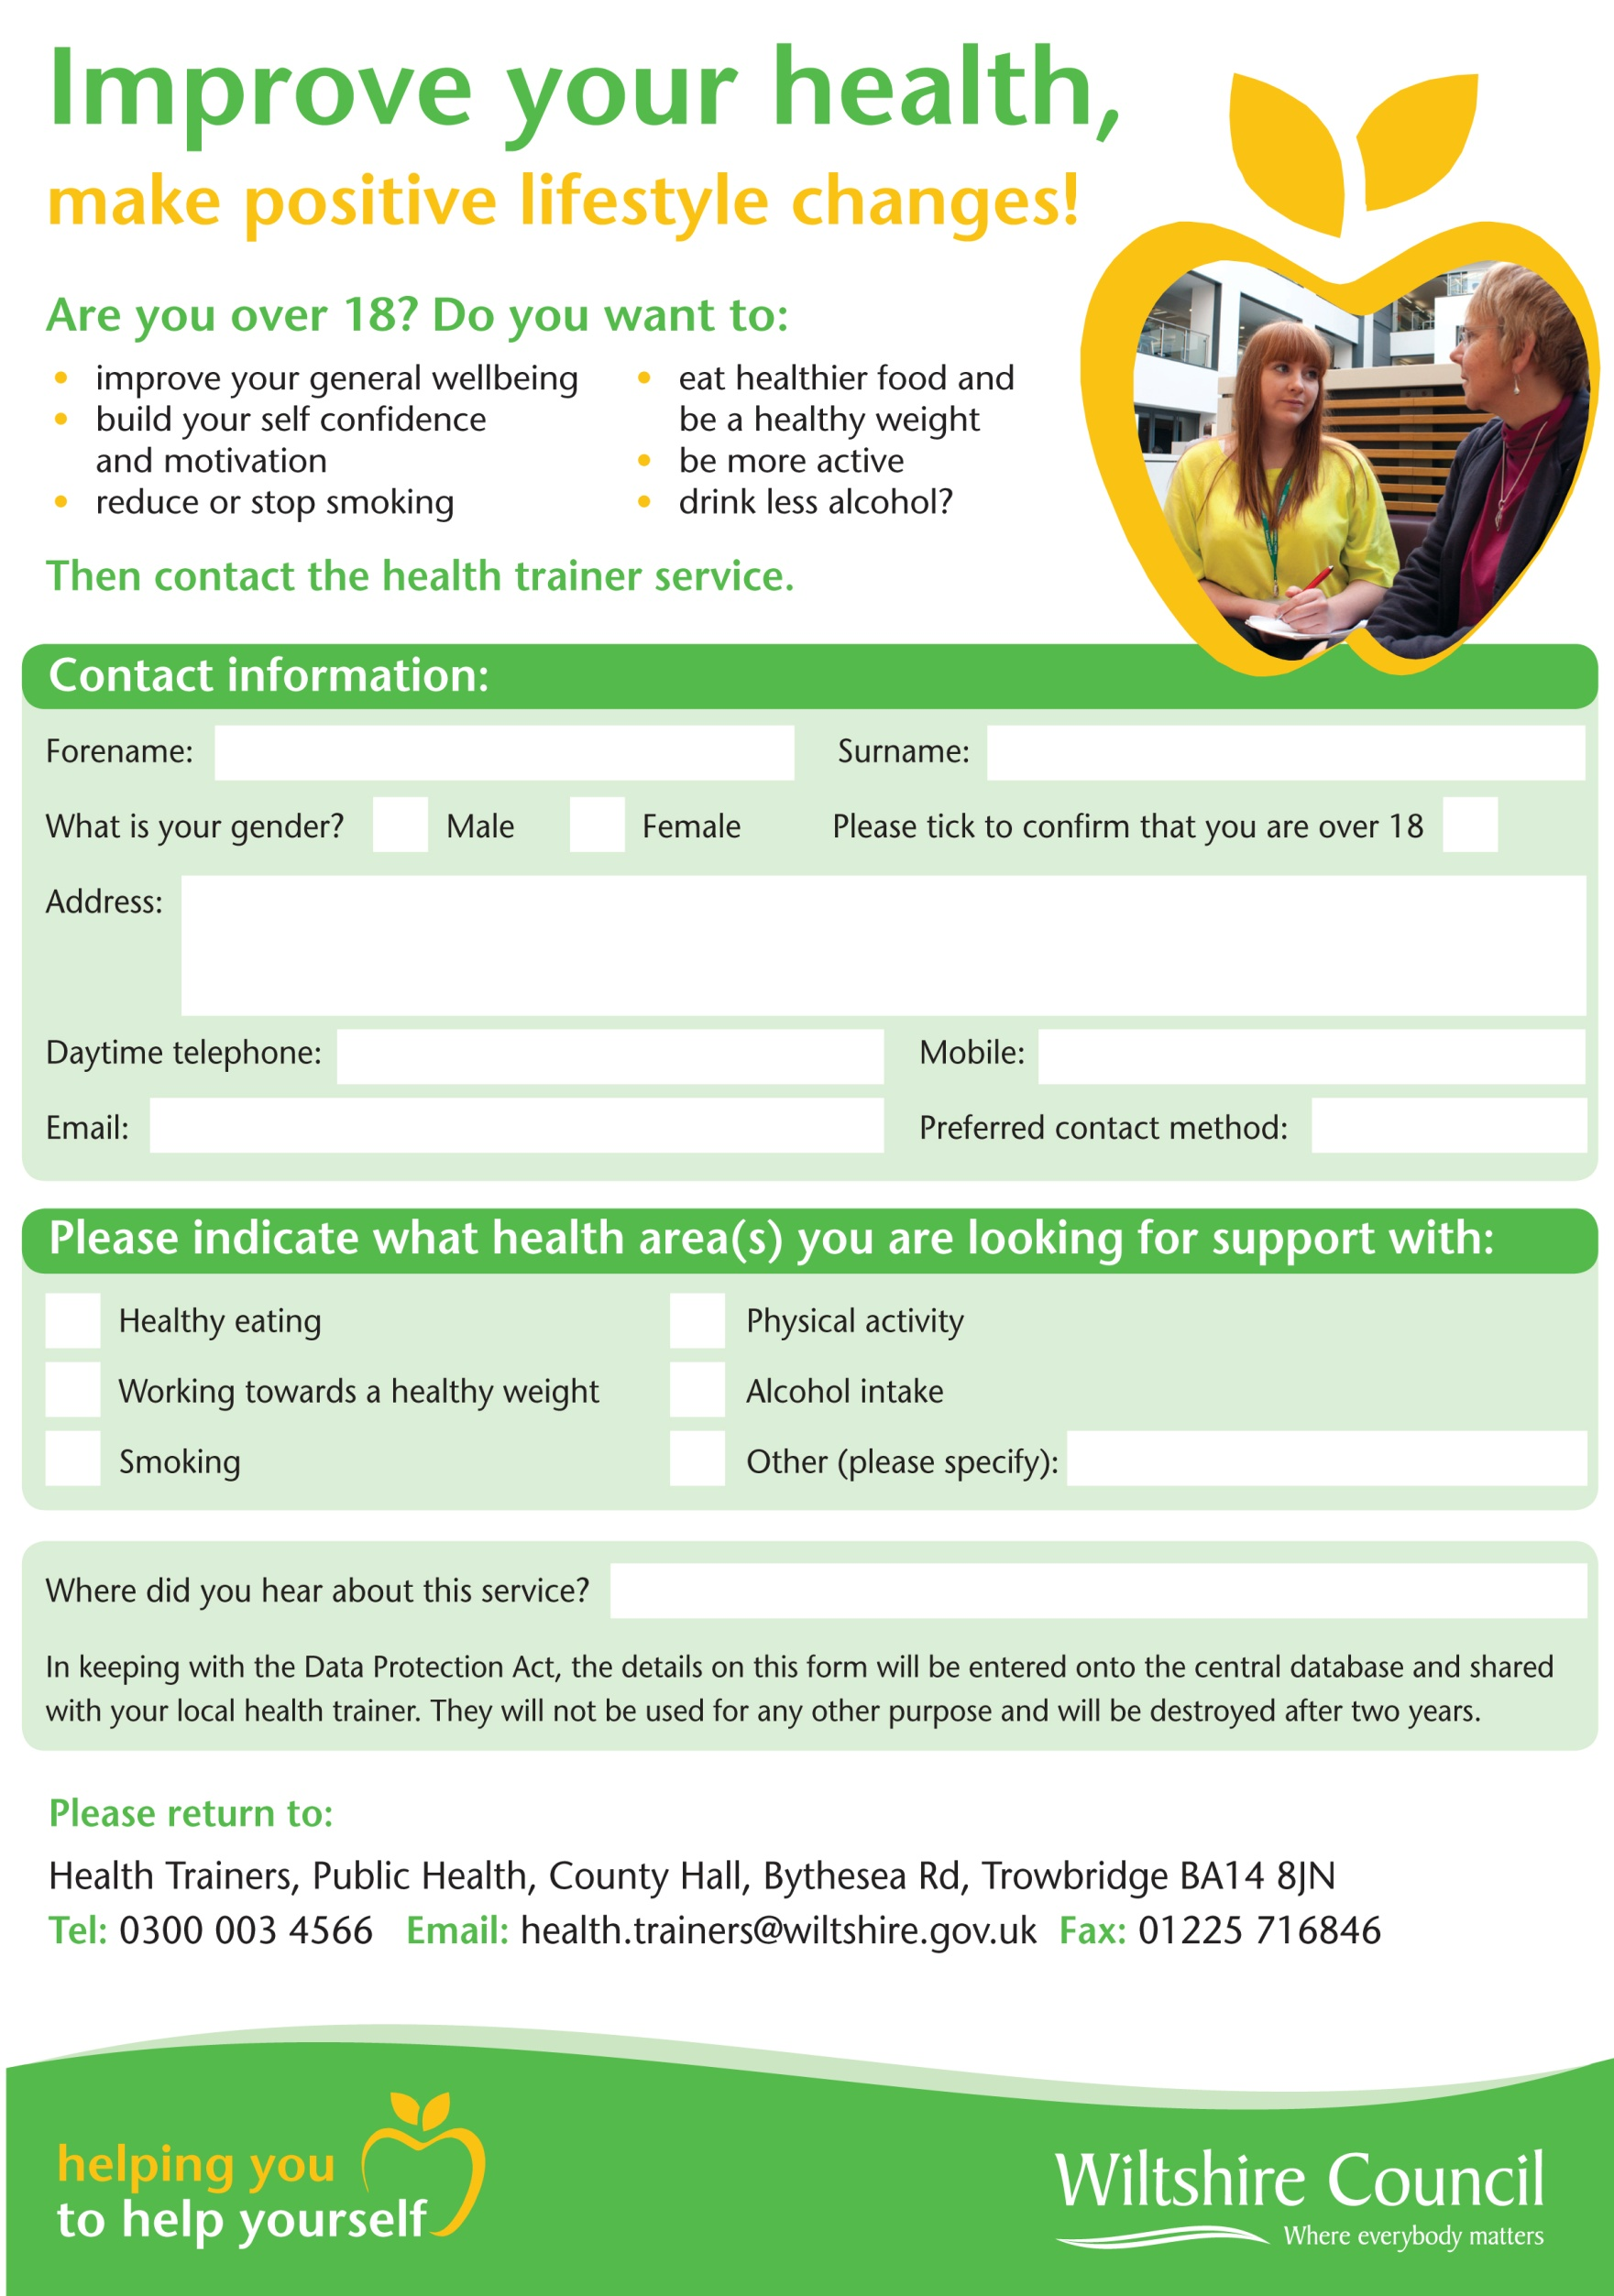

**Email:** WCOUNCIL.healthtrainers@nhs.net